DEPARTMENT: | Computer Science | PROGRAM: | Information Technology
COURSE: | Communication Networks | LEVEL: | 4 | DATE: | 10/10/2026
INSTRUCTOR: | Ing. Gabriel Gustavo Narváez, Mgtr. | PRACTICE No. | 1 | GRADE:

Initial NIC Configuration and Network Testing
Jeffry David Vera Borja
Universidad de las Fuerzas Armadas ESPE | Santo Domingo
NRC 32804 | Academic period 202651
ABSTRACT
This laboratory examined Ethernet interface configuration and local network communication in Cisco Packet Tracer. Two desktop computers and one laptop were connected through three Cisco 2960 switches in a cascade. The hosts were configured in the 192.168.1.0/24 subnet, and their IPv4 and physical addresses were verified with ipconfig /all. Switch MAC address tables were compared with the physical topology and the traffic generated during testing. PC1 successfully reached the laptop and PC2 with four replies and no packet loss in the recorded successful tests. Other snapshots captured complete ping failures, which were analyzed separately. A trace to PC2 displayed one IP hop even though the frames crossed three switches. Simulation events corroborated the forward and return paths. The results distinguish physical and logical addressing, demonstrate dynamic MAC learning, and show why link status, ping output, and routing diagnostics must be interpreted together.
Keywords: network interface card, IPv4, MAC learning, ICMP, Packet Tracer.

1 INTRODUCTION
A working local area network requires both an operational Ethernet connection and correct logical addressing. A green link indicator alone does not demonstrate that an application can exchange packets with another host. Interface inspection, address verification, switching information, and connectivity tests provide complementary evidence of network operation.
This practice follows the initial NIC configuration and network testing activities in the laboratory guide [1]. It examines one local subnet without a router, using PC1, Laptop, and PC2 as the three end devices. The report relates the command output to the actual switch ports and explains the successful tests, the unsuccessful attempts, and the packet movement observed in Simulation mode.

2 OBJECTIVES
General objective
Configure and verify a small Ethernet LAN, relating NIC settings and IPv4 addressing to MAC learning and end-to-end connectivity.
Specific objectives
• Identify the FastEthernet0 interface and distinguish its physical address from its assigned IPv4 address.
• Verify unique host addresses and a common /24 subnet mask on all three end devices.
• Interpret dynamic MAC entries and associate them with access ports and inter-switch links.
• Evaluate ping and tracert results and relate them to the packet path observed in Simulation mode.

3 THEORETICAL FRAMEWORK

3.1 Network interfaces and addressing
A network interface card provides the connection between an end device and the network medium. In this topology, the wired interface is FastEthernet0. Its 48-bit MAC address identifies the Ethernet interface, while its IPv4 address is a configurable logical address used for IP communication. A device can have several interfaces, so the physical address must be read under the interface actually connected to the LAN.
The subnet mask 255.255.255.0 is equivalent to /24. For the three configured addresses, the network address is 192.168.1.0 and the broadcast address is 192.168.1.255. The usable host range is 192.168.1.1 through 192.168.1.254. Because the tested hosts belong to the same subnet, their local exchanges do not require a default gateway.

3.2 Switching and address resolution
A switch learns the source MAC address of a received frame and associates it with the incoming port and VLAN. It uses destination MAC entries to select an outgoing port; unknown unicast traffic is flooded within the VLAN except through the ingress port. Dynamic entries age out when they are not refreshed, so a table is a time-dependent view rather than a permanent inventory [2].
ARP resolves an IPv4 address to an Ethernet address on the local link. When the mapping is unknown, the sender broadcasts a request and the target returns its MAC address. A cached mapping can be reused for subsequent traffic [3]. An ARP table maps IP addresses to MAC addresses, whereas a switch MAC table maps MAC addresses to ports. These tables serve different purposes.

3.3 Diagnostic commands
Command | Purpose in this practice
ipconfig /all | Inspect each host interface, physical address, IPv4 address, subnet mask, and gateway [4].
show mac address-table | Inspect the VLAN, learned MAC address, entry type, and forwarding port on each switch [2].
ping <destination> | Send ICMP Echo Requests and record replies, loss, and round-trip time [5].
tracert <destination> | Identify IP hops using probes with increasing TTL values [6].

Layer 2 switches forward Ethernet frames without acting as IP routers. They therefore do not appear as separate hops in this trace. The destination can be listed as hop 1 even when several switches carry the frames between the hosts. Simulation mode reveals those Layer 2 devices and complements the IP-level trace.

4 DESCRIPTION OF THE PROCEDURE

4.1 Equipment and working environment
The simulated network used three Cisco 2960-24TT switches, two PC-PT computers, one Laptop-PT device, and Ethernet links. The saved topology was lab_1.pkt. Host-to-switch links used FastEthernet interfaces, and the switches were interconnected through GigabitEthernet ports. All shown dynamic MAC entries belonged to VLAN 1.
The workflow consisted of checking the topology and NIC settings, verifying the host addresses, querying switch MAC tables, interpreting connectivity tests, and observing packet movement. The following figures present the configuration evidence and command results by activity.

4.2 Topology and port connections
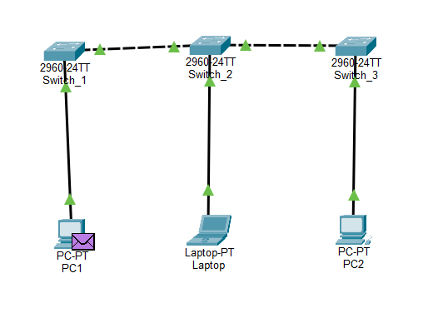
Figure 1. Three-switch cascade with PC1, Laptop, and PC2.
PC1 connects to Switch_1, Laptop to Switch_2, and PC2 to Switch_3. The visible green indicators show active links in this snapshot. The intermediate switches extend the Ethernet path without introducing additional IP subnets.
Table 1. Connections used in the simulated LAN.
Endpoint A | Interface A | Endpoint B | Interface B
PC1 | FastEthernet0 | Switch_1 | FastEthernet0/1
Laptop | FastEthernet0 | Switch_2 | FastEthernet0/1
PC2 | FastEthernet0 | Switch_3 | FastEthernet0/1
Switch_1 | GigabitEthernet0/1 | Switch_2 | GigabitEthernet0/1
Switch_2 | GigabitEthernet0/2 | Switch_3 | GigabitEthernet0/1

Table 2. Verified host addressing on the wired interfaces.
Host | IPv4 address | Subnet mask | FastEthernet0 MAC
PC1 | 192.168.1.10 | 255.255.255.0 | 0060.2F97.70AB
Laptop | 192.168.1.20 | 255.255.255.0 | 00D0.D3BD.38D0
PC2 | 192.168.1.30 | 255.255.255.0 | 00E0.F915.1D7E

The addresses are distinct and share the same network prefix. The default gateway and DNS fields display 0.0.0.0 in the host output. These settings do not prevent direct tests by IPv4 address within this subnet. They do not establish connectivity to remote networks or name resolution services.

4.3 Inspection and configuration of the NIC
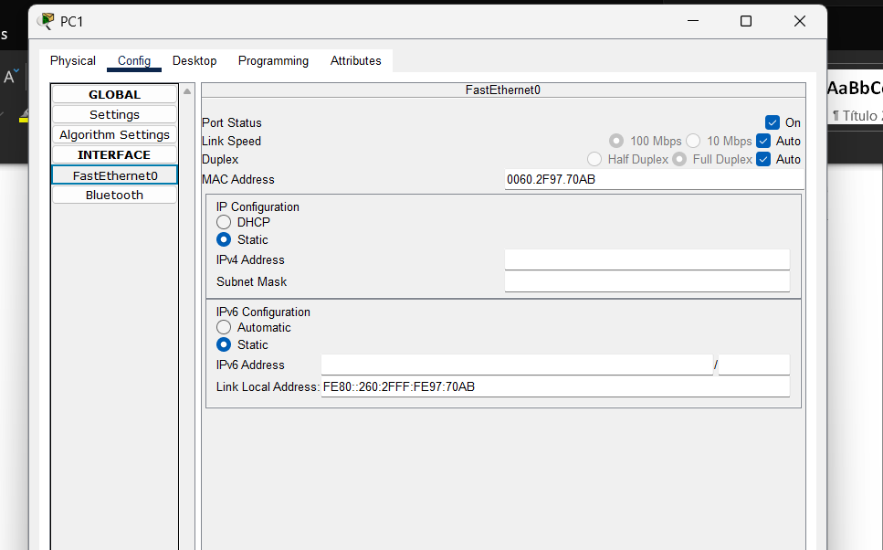
Figure 2. PC1 FastEthernet0 before static IPv4 values were entered.
The Config tab identifies FastEthernet0 and shows its physical address, 0060.2F97.70AB. In this initial view, the IPv4 address and subnet mask fields are blank. This is an interface configuration screen; it does not show a physical module installation.
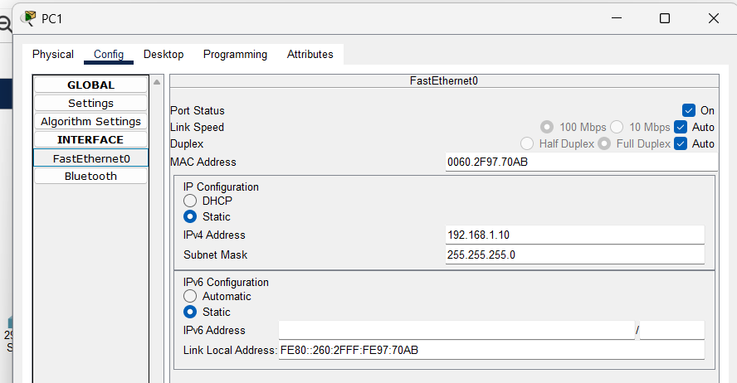
Figure 3. PC1 FastEthernet0 configured as 192.168.1.10 with mask 255.255.255.0.
The port is enabled, static IPv4 addressing is selected, and speed and duplex remain on Auto. The assigned IPv4 address places PC1 in the planned subnet while its MAC address remains unchanged. The comparison separates a configurable network address from the interface hardware identifier.

4.4 Verification on PC1
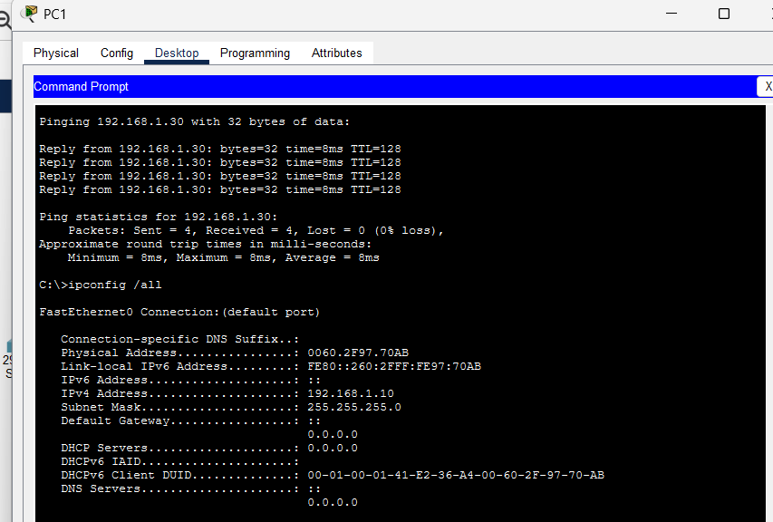
Figure 4. PC1 ipconfig /all output and successful ping to PC2.
The FastEthernet0 section confirms IPv4 address 192.168.1.10, subnet mask 255.255.255.0, and physical address 0060.2F97.70AB. A link-local IPv6 address also appears, but the tests analyzed here use IPv4. The displayed gateway and DNS values are 0.0.0.0.
The same capture records a successful ping to 192.168.1.30. All four 32-byte probes receive replies with TTL 128. The statistics report 4 sent, 4 received, 0 lost, and 0% loss. Minimum, maximum, and average round-trip times are all 8 ms in this run. These measurements establish successful PC1-to-PC2 communication at the time of the capture.
A successful ping requires traffic to travel to the destination and a reply to return. Consequently, this result demonstrates a working round trip across the cascade. It does not by itself identify every intermediate switch or prove that all other host pairs were tested successfully.

4.5 Verification on Laptop and PC2
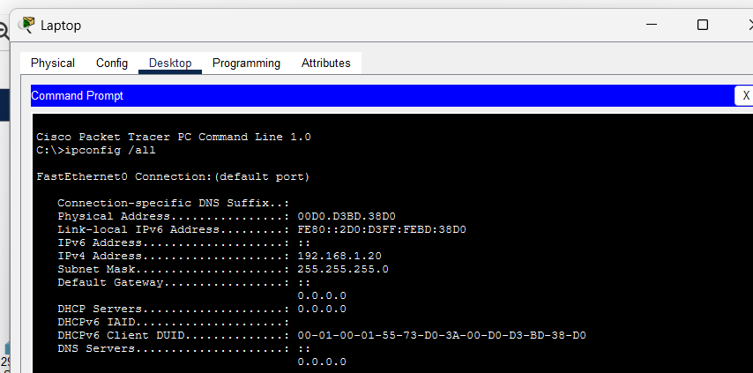
Figure 5. Laptop FastEthernet0 addressing reported by ipconfig /all.
Laptop uses 192.168.1.20/24 and MAC address 00D0.D3BD.38D0. These values identify the host connected to Switch_2 FastEthernet0/1 and allow its address to be recognized in subsequent switch tables.
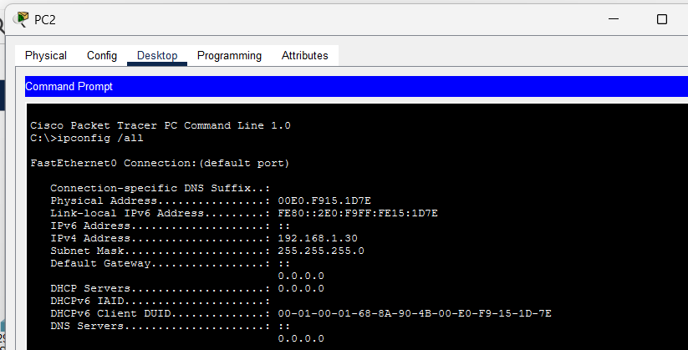
Figure 6. PC2 FastEthernet0 addressing reported by ipconfig /all.
PC2 uses 192.168.1.30/24 and MAC address 00E0.F915.1D7E. PC2 is the third end device in this topology. The three ipconfig outputs agree with Table 2 and provide the reference values used to interpret MAC learning.

4.6 Initial learning and the PC1 to Laptop test
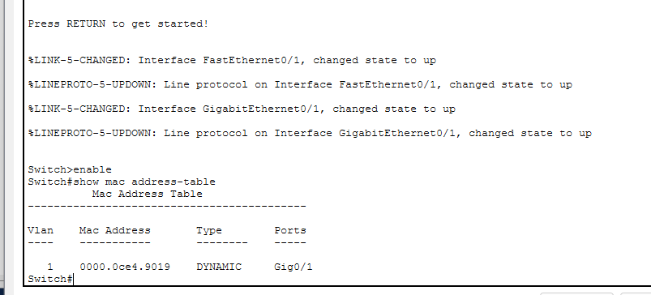
Figure 7. Initial Switch_1 MAC table with one dynamic entry.
The initial query contains 0000.0CE4.9019 on Gig0/1 in VLAN 1. PC1 and Laptop are not yet listed in this snapshot. A table can contain switch-related traffic entries before the end-device addresses relevant to the test have been learned.
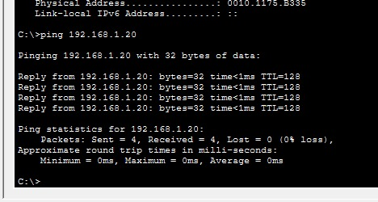
Figure 8. Successful ping from PC1 to 192.168.1.20.
The test returns four replies with time below 1 ms and TTL 128. The summary reports no lost packets and displayed minimum, maximum, and average times of 0 ms. This rounded display does not mean that transmission requires zero time.
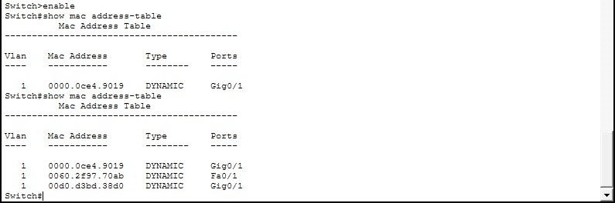
Figure 9. Switch_1 table comparison before and after the host exchange.
The later query adds PC1 MAC 0060.2F97.70AB on Fa0/1 and Laptop MAC 00D0.D3BD.38D0 on Gig0/1. PC1 is directly attached; the laptop is reached through the uplink to Switch_2. The observed entries match the physical connections and illustrate source MAC learning.

4.7 Switch_2 observations and an unsuccessful test
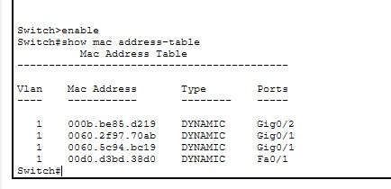
Figure 10. Switch_2 learns PC1 through Gig0/1 and Laptop through Fa0/1.
The table associates 0060.2F97.70AB with Gig0/1 and 00D0.D3BD.38D0 with Fa0/1. It also contains 000B.BE85.D219 on Gig0/2 and 0060.5C94.BC19 on Gig0/1. PC2 MAC 00E0.F915.1D7E is absent from this snapshot.
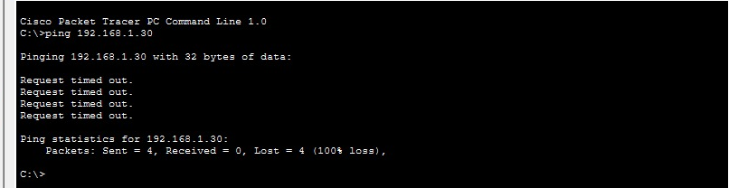
Figure 11. Laptop ping to PC2 with four timeouts and 100% packet loss.
The command ping 192.168.1.30 sends four probes and receives no replies. This is a failed test, not a successful connectivity result. The output alone does not determine whether the cause was configuration, link state, simulation progress, or another temporary condition.
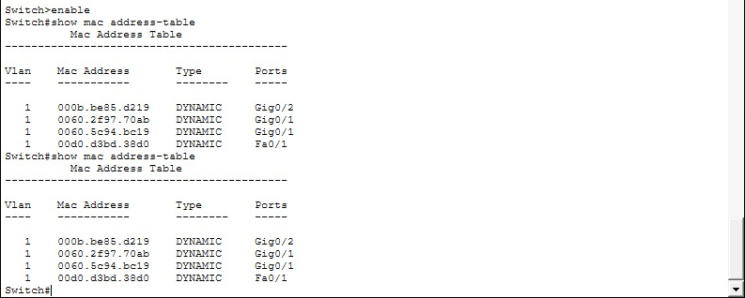
Figure 12. Repeated Switch_2 queries showing the same four dynamic entries.
Both visible queries contain the same entries, including Laptop on Fa0/1. Repeating a display command does not create a new learned host entry. The table and the failed ping together document the observed state, but they do not establish a specific corrective action.

4.8 Switch_3 observations and the reverse test
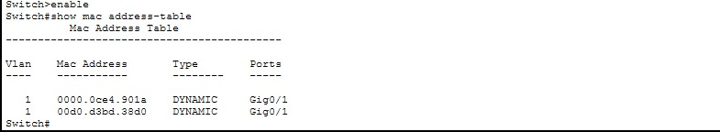
Figure 13. Early Switch_3 table with two entries through Gig0/1.
The table contains 0000.0CE4.901A and Laptop MAC 00D0.D3BD.38D0 on Gig0/1. The local PC2 MAC is not listed in this view. The laptop entry is consistent with traffic arriving from the upstream switch.
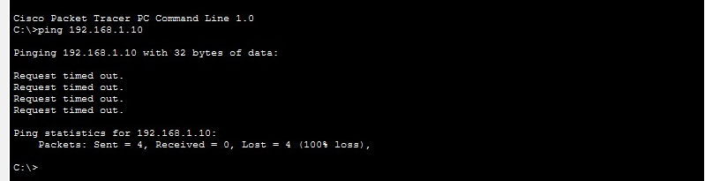
Figure 14. PC2 ping to PC1 with four timeouts and 100% packet loss.
PC2 attempts to reach 192.168.1.10, but all four probes time out. This result must be distinguished from the successful PC1-to-PC2 run in Figure 4. The captures represent different observed states; the failed reverse attempt does not erase the independently recorded successful round trip.
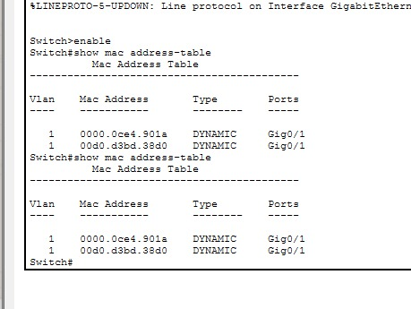
Figure 15. Repeated early Switch_3 MAC table queries.
The repeated output again shows the same two upstream entries. No local PC2 entry appears in these two queries. Later tables show a different learned state, which supports comparing snapshots over time instead of treating one table as a complete inventory of connected devices.

4.9 Later MAC tables across the cascade
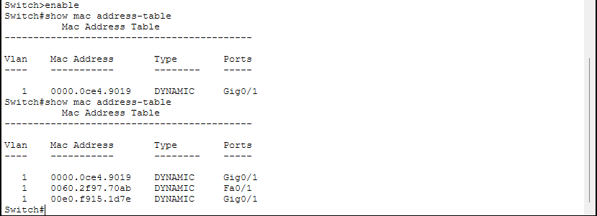
Figure 16. Later Switch_1 table with PC1 on Fa0/1 and PC2 on Gig0/1.
Switch_1 reaches the local PC1 through Fa0/1 and the remote PC2 through Gig0/1. The additional 0000.0CE4.9019 entry remains on the uplink. Laptop is not present in this later table.
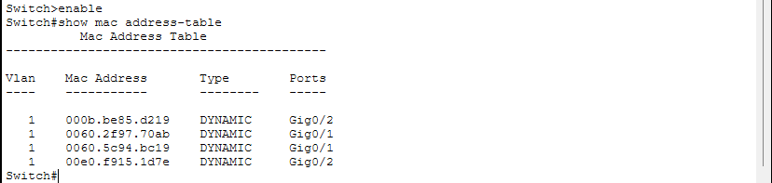
Figure 17. Later Switch_2 table with PC1 on Gig0/1 and PC2 on Gig0/2.
Switch_2 separates the two endpoint directions: PC1 is learned to the left through Gig0/1 and PC2 to the right through Gig0/2. The table also includes two other dynamic entries. The laptop entry seen earlier is absent from this snapshot.
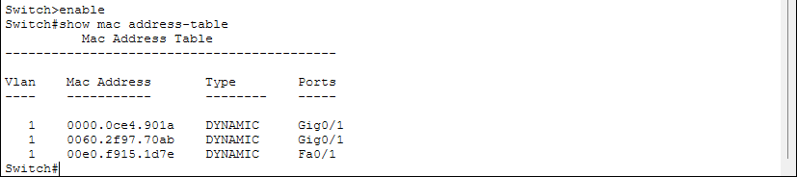
Figure 18. Later Switch_3 table with PC1 on Gig0/1 and PC2 on Fa0/1.
Switch_3 learns the remote PC1 through Gig0/1 and the directly attached PC2 through Fa0/1. All three tables therefore agree on the endpoint directions. Dynamic aging or changes in recent traffic can explain differences between snapshots, but these captures do not establish the exact reason an earlier entry disappeared.

4.10 IP trace and Simulation event sequence
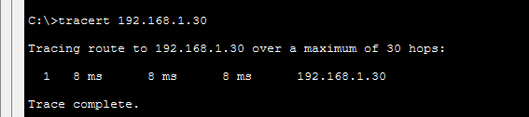
Figure 19. Trace from PC1 to PC2 ending at hop 1.
The command tracert 192.168.1.30 reaches the destination in one displayed hop. Its three probe times are 8 ms, 8 ms, and 8 ms. The three switches remain part of the physical path but are not IP routing hops. The trace therefore agrees with a single-subnet switched LAN [6].
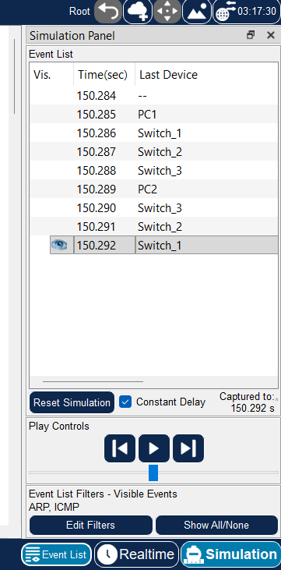
Figure 20. Simulation Event List with ARP and ICMP filters selected.
The Last Device sequence progresses through PC1, Switch_1, Switch_2, Switch_3, PC2, Switch_3, Switch_2, and Switch_1. This sequence corroborates movement toward PC2 and back toward PC1. The ARP and ICMP filter labels specify which protocols are enabled for display; they do not, by themselves, prove that a new ARP exchange occurred during this particular capture.

4.11 Visual packet path through the switches
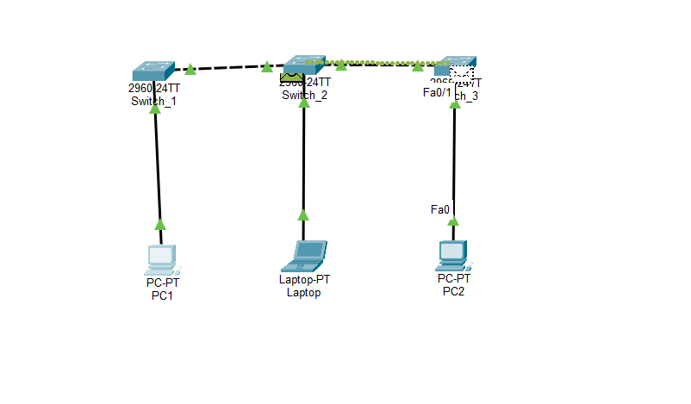
Figure 21. Packet envelope on the link between Switch_2 and Switch_3.
The envelope is visible on the right-hand inter-switch link. Together with the event sequence, this position illustrates forwarding through the cascade toward the destination side of the LAN.
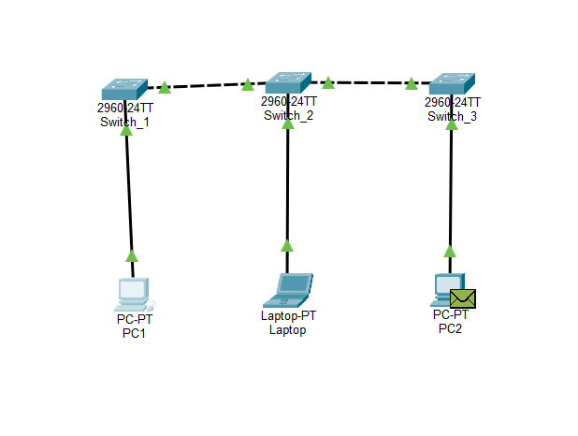
Figure 22. Packet envelope at PC2 on the right side of the topology.
PC2 is connected to Switch_3 FastEthernet0/1. The envelope at this endpoint is consistent with arrival at the destination. Packet type and direction should be confirmed from event details rather than inferred solely from an envelope icon.

4.12 Return path toward PC1
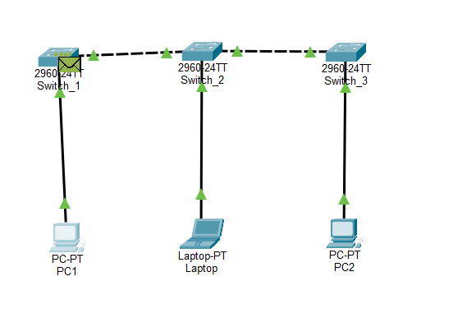
Figure 23. Packet envelope at Switch_1 during the observed exchange.
The envelope is now visible at the left-hand switch. The event list places Switch_1 after Switch_2 on the return sequence, which supports interpreting this position as part of the movement back toward PC1.
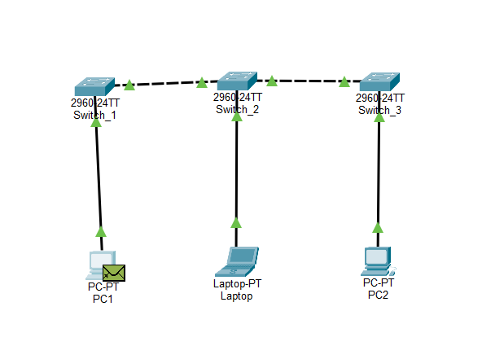
Figure 24. Packet envelope at PC1 at the left endpoint.
The final pictured endpoint is PC1. The sequence of topology captures complements the successful ping statistics: the frame path includes all three switches, while the IP trace identifies only the destination hop. The screenshots illustrate location; the command output provides the quantitative evidence of successful replies.

5 ANALYSIS OF RESULTS

5.1 Connectivity measurements
Table 3. Recorded connectivity tests and their scope.
Test | Sent / received | Loss | Recorded result
PC1 to Laptop  192.168.1.20 | 4 / 4 | 0% | Four replies, each below 1 ms; TTL 128. Figure 8.
Laptop to PC2  192.168.1.30 | 4 / 0 | 100% | Four timeouts in the captured attempt. Figure 11.
PC2 to PC1  192.168.1.10 | 4 / 0 | 100% | Four timeouts in the captured attempt. Figure 14.
PC1 to PC2  192.168.1.30 | 4 / 4 | 0% | Four replies, each 8 ms; TTL 128. Figure 4.

The successful tests validate the corresponding exchanges at the times shown. They do not justify reporting every captured test as successful. The two failed attempts remain part of the results because their statistics explicitly show that no Echo Replies were received. No successful repeat of the Laptop-to-PC2 test is shown.

5.2 Relationship between learned addresses and ports
Table 4. Endpoint entries in the later MAC tables in Figures 16 to 18.
Switch | PC1 MAC 0060.2F97.70AB | PC2 MAC 00E0.F915.1D7E
Switch_1 | Fa0/1 | Gig0/1
Switch_2 | Gig0/1 | Gig0/2
Switch_3 | Gig0/1 | Fa0/1

An access-port entry identifies a directly attached endpoint; an uplink entry identifies the direction toward a remote endpoint. The same host MAC is therefore associated with different ports on different switches. The MAC itself does not change as the frame crosses this Layer 2 path.

5.3 Answers to the key laboratory questions
What distinguishes a MAC address from an IPv4 address?
The MAC identifies the Ethernet interface for local frame delivery. The IPv4 address is the logical address assigned to the host for IP communication. PC1 retains MAC 0060.2F97.70AB while its IPv4 fields change from blank to 192.168.1.10/24.
Why can the hosts communicate without a configured gateway?
All three addresses belong to 192.168.1.0/24. A host can deliver traffic directly to another host on the same subnet after resolving its MAC address. A gateway is needed for destinations outside that subnet, which were not part of these tests.
Why does tracert show one hop through three switches?
Tracert exposes IP forwarding hops through TTL behavior. These switches forward at Layer 2 and do not count as routers. PC2 responds as the first displayed IP hop even though the Ethernet frames cross the three switches.

6 GRAPHICS AND PHOTOGRAPHS
The 24 numbered figures are integrated into Section 4 beside the corresponding procedures and interpretations. Figures 1 to 6 document topology and addressing; Figures 7 to 18 document switching and connectivity; Figures 19 to 24 document tracing and packet movement. Command-output excerpts retain the values and statistics needed to verify each result.

7 DISCUSSION
The address outputs, learned MAC entries, and successful PC1-to-PC2 ping are mutually consistent. Each endpoint belongs to the same /24 subnet, and the later switch tables point to the correct local or remote direction. This agreement links the logical addressing plan to the physical topology and to a completed packet exchange.
The failed tests show why troubleshooting should combine several observations. A timeout proves that an expected reply was not received within the test interval, but it does not identify a unique fault. Checking the active interface, IPv4 address, mask, cabling, port state, and simulation progress would help isolate the cause. A missing MAC entry is also insufficient to prove that a host is disconnected, because entries depend on recently observed source traffic.
The displayed delay values are simulator measurements. The 8 ms replies and the sub-millisecond replies belong to different runs, and the Event List shows Constant Delay selected. These values should not be treated as a benchmark of real switch performance or as evidence that adding a particular switch caused a specific delay.
Finally, selecting ARP in the Simulation filters is not equivalent to capturing an ARP request and reply. The screenshots establish the selected filters and the device sequence, but they do not expose an ARP packet detail view. The role of ARP is explained by the protocol, while the observed round trip is supported directly by the ping output and the displayed path.

8 CONCLUSIONS
• The three wired interfaces were identified and verified with unique IPv4 addresses in 192.168.1.0/24. Their physical addresses supplied the identifiers needed to interpret the switch tables.
• The MAC table comparisons demonstrate learning consistent with the topology: local endpoint addresses appear on Fa0/1, while remote endpoint addresses appear on the appropriate GigabitEthernet uplinks.
• PC1 successfully reached Laptop and PC2 in the recorded successful runs with four replies and 0% loss. The separate Laptop-to-PC2 and PC2-to-PC1 attempts recorded 100% loss and must remain classified as unsuccessful observations.
• The trace to PC2 completed at hop 1 because the three intermediate devices operated as Layer 2 switches. Simulation mode revealed their participation in the physical path without contradicting the IP trace.
• Reliable network verification requires correlating interface configuration, switch learning, command statistics, and packet events. No single screenshot establishes every aspect of network operation or the cause of a failed test.

9 BIBLIOGRAPHY
[1] Universidad de las Fuerzas Armadas ESPE. Initial NIC Configuration and Network Testing. Laboratory Practice 1, Communication Networks, NRC 32804, academic period 202651. Course laboratory guide.
[2] Cisco Systems. Catalyst 2960, 2960-S, and 2960-P Switch Software Configuration Guide, Cisco IOS Release 15.0(2)EZ. Administering the Switch, MAC address table management. Accessed October 12, 2026. https://www.cisco.com/c/en/us/td/docs/switches/lan/catalyst2960/software/release/15-0_2_ez/configuration/guide/scg_2960/swadmin.html
[3] D. C. Plummer. An Ethernet Address Resolution Protocol. RFC 826, November 1982. RFC Editor. https://www.rfc-editor.org/rfc/rfc826
[4] Microsoft. ipconfig. Windows command documentation, Microsoft Learn. Accessed October 12, 2026. https://learn.microsoft.com/en-us/windows-server/administration/windows-commands/ipconfig
[5] Microsoft. ping. Windows command documentation, Microsoft Learn. Accessed October 12, 2026. https://learn.microsoft.com/en-us/windows-server/administration/windows-commands/ping
[6] Microsoft. tracert. Windows command documentation, Microsoft Learn. Accessed October 12, 2026. https://learn.microsoft.com/en-us/windows-server/administration/windows-commands/tracert
The Microsoft references describe the diagnostic commands and their interpretation. The numerical results and device outputs in this report are from the Cisco Packet Tracer experiment.

